**Answer Sheet - SQL**

Name : Aman Kumar

Batch No. : 6

Phone No. : 9456644181

Email : amanchahar005@gmail.com

**Major Question 1**

1. List the salary of all the employees.



Insert Image-

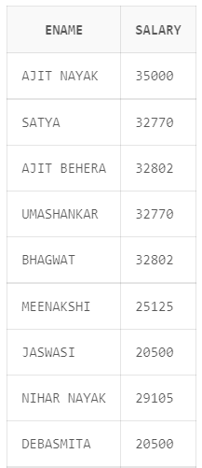

1. Display the names of all employees with any “A” at any place of the name.



Insert Image –

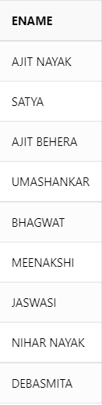

1. Show all employees who were hired in the first half of the month (Before the 16th of the month).

Insert Image - 



1. Display the name of all female employees.



Insert Image -

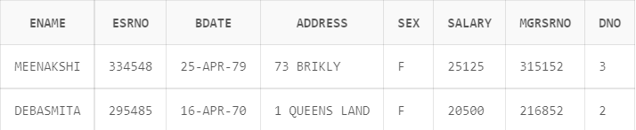

1. Display the employee who is paid most in the company.



Insert Image –

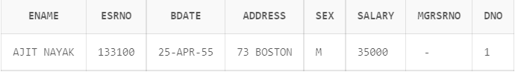

**Major Question 2**

1. Display employee name, address, department no and department name.



Insert Image –

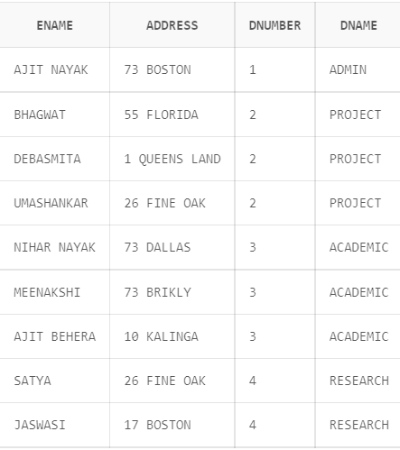

1. Display all the employees who are *not in* ACADEMIC department



Insert Image –

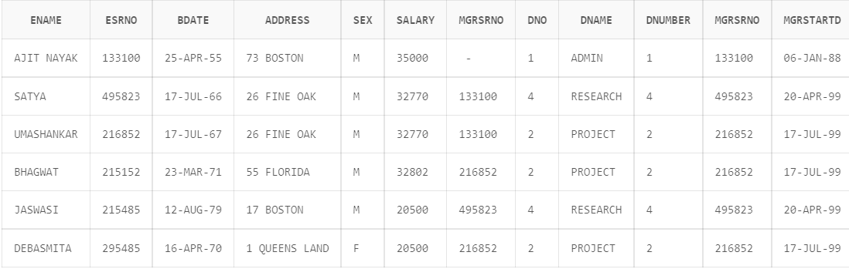

1. Display SATYAS’ project location.



Insert Image -

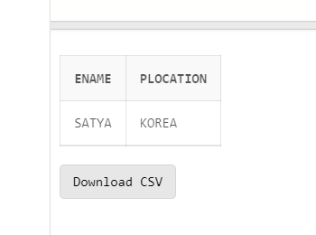

1. Find the total working hours of *each* female employee.



Insert Image -

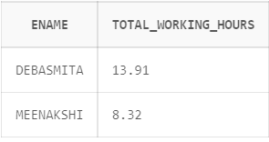

1. Display the details of the people whose projects are located at SOUTH AFRICA.



Insert Image -

